Assessment Schedule – 2013

Physics: Demonstrate understanding of electricity and electromagnetism (91173)

Evidence Statement
For all questions:
NØ | N1 | N2 | A3 | A4 | M5 | M6 | E7 | E8
No evidence | 1a | 2a | 3a | 4a | 3a+1m | 2a+2m | 2m+1e | 1m+2e
Other combinations are also possible. However, in order to get M5 or M6, there should be at least one Merit question correct. To get E7 or E8, there should be at least one Excellence question correct.
Q | Evidence | Achievement | Merit | Excellence
ONE  (a) | 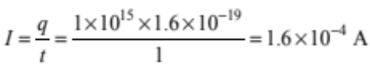 | Correct.
(b) | The electron is moving in the same direction as the magnetic field.  So the magnetic force acting on the electron is zero. | One correct statement. | Correct explanation.
(c) | 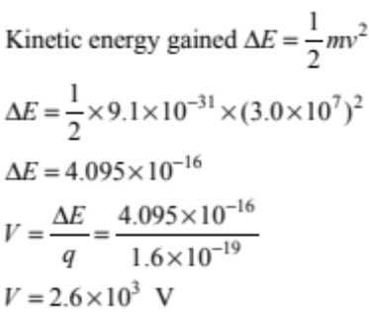 | One correct equation and substitution. | Correct working except for one error. | Correct working AND answer.
(d) | 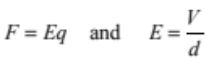  So if the distance between the plates is halved, the electric field strength doubles.  This will cause the force on the electron to double.  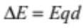  So if the electric field strength doubles and the distance is halved, the gain in KE is the same. | One correct statement. | Two correct statements. | Correct answer AND explanation.
TWO  (a) | 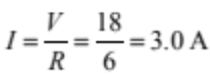 | accept 3A.
(b) | P = VI and V = IR  So doubling the voltage will also double the current.  This will increase the power by 4.  OR use 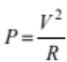 | Correct answer. | Correct answer AND explanation.
(c) | 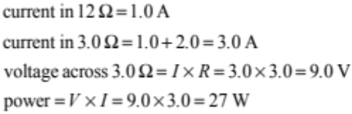 | One correct equation and substitution. | Correct working except for one error. | Correct working and answer.

(d) | If the 12 Ω resistor is removed, the total resistance will increase.  The total current will decrease (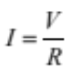).  The current through the 3 Ω resistor will decrease.  The voltage across the 3 Ω resistor will decrease.  OR  Total voltage = 21 V shared in ratio 1:2  So voltage across 3 Ω resistor is 7 V  So voltage drops. | One correct statement. | Two correct statements. | Correct answer AND explanation.
THREE  (a) | Out of the page  Towards the top of the page. | One correct. | Both correct.
(b) | 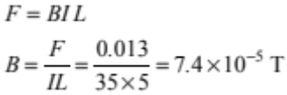 | Correct.
(c) | 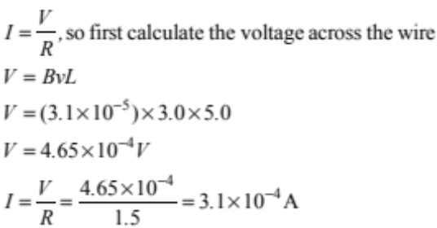 | One correct equation and substitution. | Correct working except for one error. | Correct working and answer.
(d) | The current in the wire will become zero.  There are now two wires cutting across the field in the same direction.  Each wire has the same voltage induced across it.  The two voltages are in opposite directions so they cancel out. OR total voltage = zero.  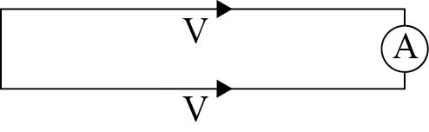 | One correct statement. | Two correct statements. | Correct answer AND explanation.

Judgement Statement
 | Not Achieved | Achievement | Achievement  with Merit | Achievement  with Excellence
Score range | 0 – 6 | 7 – 12 | 13 – 18 | 19 – 24

